PENGAJUAN DANA 16 AGUSTUS 2024

1. SAMSAT MAZDA B 1781 ZKW

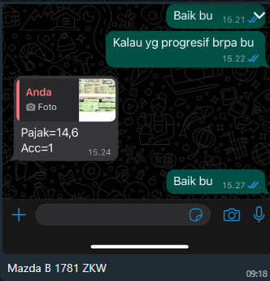

1. SAMSAT LEXUS NX300 B 1 ALN

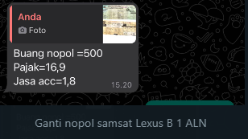

1. CAT RONY S ORANGE AB 1687 YJ

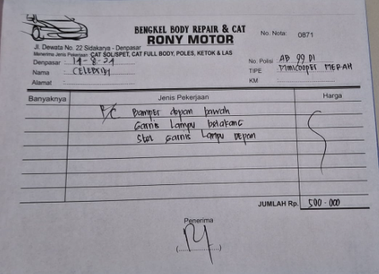

1. TOWING RUBICON JKT-DPS B 1780 BJT (VIA TELFON)
2. GANTI OLI CRV PUTIH DK 1418 BG (via telfon)
3. COVER BAN SEREP JEEP RUBICON 2015 B 1454 EUY

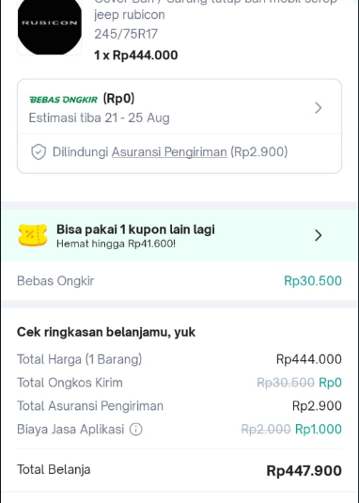

1. DP PART FERRARI MERAH (via telfon aldo)
2. BELI DONGKRAK HARLEY 2PCS

